**Lab 0 - SETUP LAB ENVIRONMENT**

1. **Netbeans IDE PHP Installer**

A, Install Netbean IDE

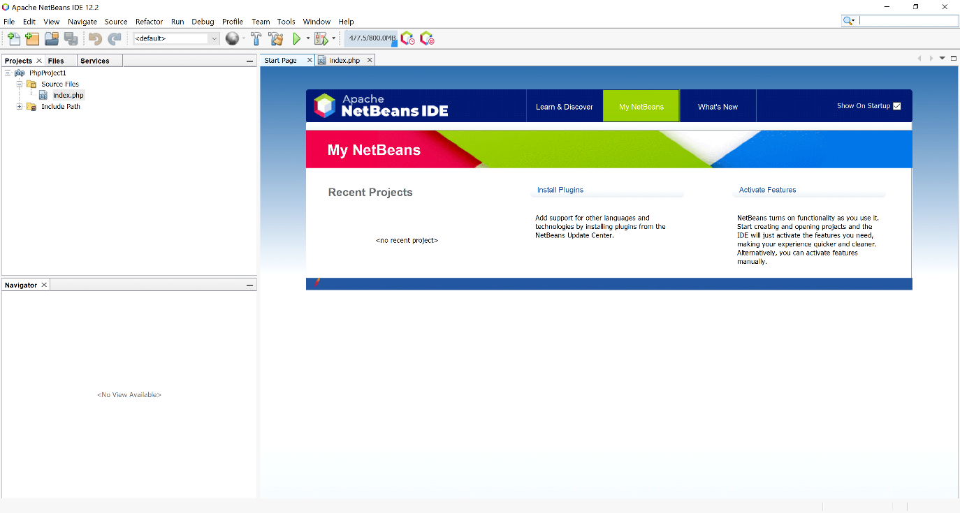

B, Set up a PHP project in the Netbeans IDE

* Tạo mới project PHP

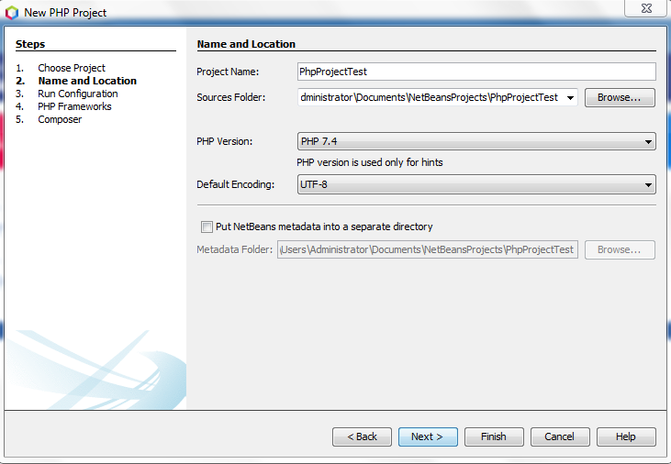

Chọn URL chạy Project: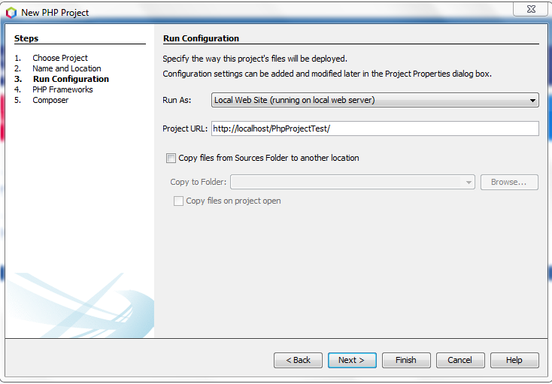

C, Run first PHP project

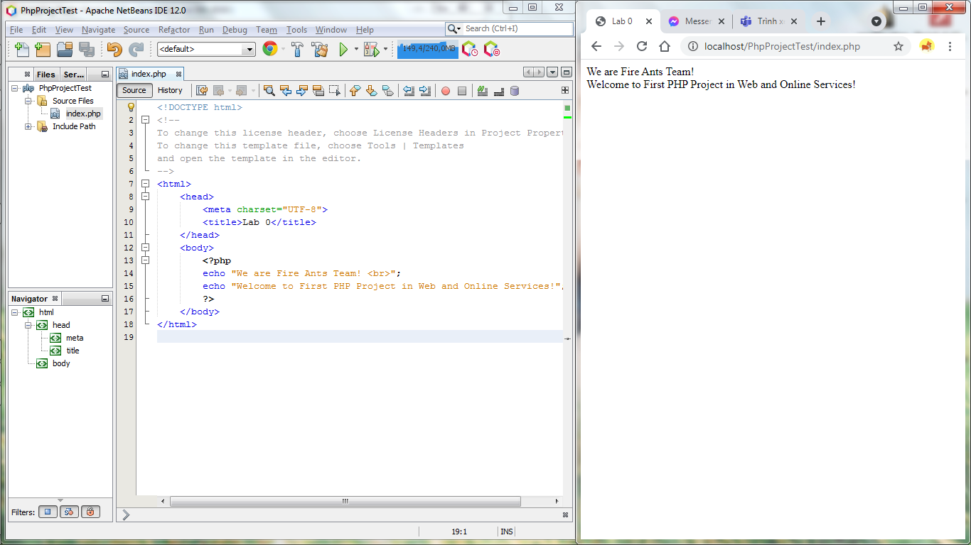

1. **MySQL Installer**

A, MySQL Installer

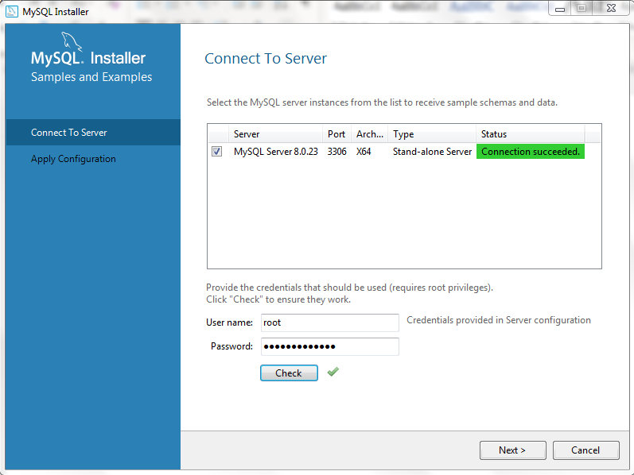

B, Create first Database in MySQL

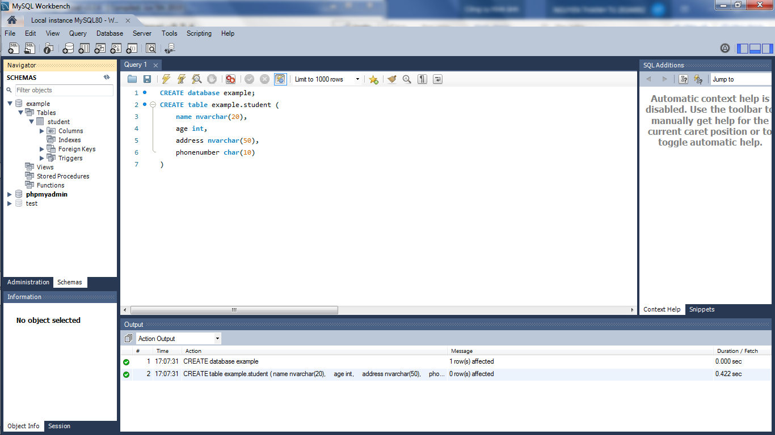

C, Connect PHP project to MySQL database

